Лабораторная работа №22

25-ПОИТ

Выполнил: Олишкевич Игорь Русланович;

Тема: создание пользовательских диалоговых окон;

Цель: сформировать умения создания пользовательских диалоговых окон в Visual Studio;

Листинг Main-формы:

using System;

using System.Collections.Generic;

using System.ComponentModel;

using System.Data;

using System.Drawing;

using System.Text;

using System.Threading.Tasks;

using System.Windows.Forms;

using System.Drawing.Drawing2D;

namespace WindowsFormsApp1

{

public partial class Form1 : Form

{

public Graphics g;

public Form1()

{

g = CreateGraphics();

InitializeComponent();

}

private void button1_Click(object sender, EventArgs e)

{

Form2 f2 = new Form2();

f2.Show();

}

private void button2_Click(object sender, EventArgs e)

{

Form3 form = new Form3(this);

form.Show();

}

private void button3_Click(object sender, EventArgs e)

{

Form4 form = new Form4();

form.Show();

}

}

}

Листинг Calculator-формы:

using System;

using System.Collections.Generic;

using System.ComponentModel;

using System.Data;

using System.Drawing;

using System.Linq;

using System.Text;

using System.Threading.Tasks;

using System.Windows.Forms;

namespace WindowsFormsApp1

{

public partial class Form2 : Form

{

public Form2()

{

InitializeComponent();

}

float a, b;

int count;

bool znak = true;

bool des = true;

bool minus = true;

private void button17_Click(object sender, EventArgs e)

{

textBox1.Text = textBox1.Text + 0;

}

private void button18_Click(object sender, EventArgs e)

{

if (des == true)

{

textBox1.Text = textBox1.Text + ",";

des = false;

}

}

private void button13_Click(object sender, EventArgs e)

{

textBox1.Text = textBox1.Text + 1;

}

private void button14_Click(object sender, EventArgs e)

{

textBox1.Text = textBox1.Text + 2;

}

private void button15_Click(object sender, EventArgs e)

{

textBox1.Text = textBox1.Text + 3;

}

private void button9_Click(object sender, EventArgs e)

{

textBox1.Text = textBox1.Text + 4;

}

private void button10_Click(object sender, EventArgs e)

{

textBox1.Text = textBox1.Text + 5;

}

private void button11_Click(object sender, EventArgs e)

{

textBox1.Text = textBox1.Text + 6;

}

private void button5_Click(object sender, EventArgs e)

{

textBox1.Text = textBox1.Text + 7;

}

private void button6_Click(object sender, EventArgs e)

{

textBox1.Text = textBox1.Text + 8;

}

private void button7_Click(object sender, EventArgs e)

{

textBox1.Text = textBox1.Text + 9;

}

private void calculate()

{

switch (count)

{

case 1:

b = a + float.Parse(textBox1.Text);

textBox1.Text = b.ToString();

break;

case 2:

b = a - float.Parse(textBox1.Text);

textBox1.Text = b.ToString();

break;

case 3:

b = a * float.Parse(textBox1.Text);

textBox1.Text = b.ToString();

break;

case 4:

b = a / float.Parse(textBox1.Text);

textBox1.Text = b.ToString();

break;

default:

break;

}

}

private void button4_Click(object sender, EventArgs e)

{

if (textBox1.Text[textBox1.Text.Length - 1] == ',')

textBox1.Text = textBox1.Text.Remove(textBox1.Text.Length - 1);

a = float.Parse(textBox1.Text);

textBox1.Clear();

count = 1;

label1.Text = a.ToString() + "+";

znak = true;

des = true;

}

private void button8_Click(object sender, EventArgs e)

{

if (textBox1.Text == "" || textBox1.Text == "-")

{

textBox1.Text = "-";

minus = false;

return;

}

if (textBox1.Text[textBox1.Text.Length - 1] == ',')

textBox1.Text = textBox1.Text.Remove(textBox1.Text.Length - 1);

a = float.Parse(textBox1.Text);

textBox1.Clear();

count = 2;

label1.Text = a.ToString() + "-";

znak = true;

des = true;

}

private void button12_Click(object sender, EventArgs e)

{

if (textBox1.Text[textBox1.Text.Length - 1] == ',')

textBox1.Text = textBox1.Text.Remove(textBox1.Text.Length - 1);

a = float.Parse(textBox1.Text);

textBox1.Clear();

count = 3;

label1.Text = a.ToString() + "*";

znak = true;

des = true;

}

private void button16_Click(object sender, EventArgs e)

{

if (textBox1.Text[textBox1.Text.Length - 1] == ',')

textBox1.Text = textBox1.Text.Remove(textBox1.Text.Length - 1);

if (textBox1.Text[0] == '-' && textBox1.Text.Length < 2)

return;

a = float.Parse(textBox1.Text);

textBox1.Clear();

count = 4;

label1.Text = a.ToString() + "/";

znak = true;

des = true;

}

private void button19_Click(object sender, EventArgs e)

{

calculate();

label1.Text = "";

}

private void button3_Click(object sender, EventArgs e)

{

textBox1.Text = "";

label1.Text = "";

znak = true;

des = true;

minus = true;

}

private void button1_Click_1(object sender, EventArgs e)

{

if (textBox1.Text[textBox1.Text.Length - 1] == ',')

textBox1.Text = textBox1.Text.Remove(textBox1.Text.Length - 1);

a = float.Parse(textBox1.Text);

double b = Math.Sqrt(a);

textBox1.Text = Convert.ToString(b);

znak = true;

des = true;

}

private void textBox1_KeyPress(object sender, KeyPressEventArgs e)

{

char number = e.KeyChar;

if (number == '-' && minus == true)

{

e.Handled = false;

minus = false;

}

if (number == ',' && des == true)

{

e.Handled = false;

des = false;

}

if (!Char.IsDigit(number))

e.Handled = true;

}

private void button2_Click(object sender, EventArgs e)

{

if (des == false && textBox1.Text[textBox1.Text.Length - 1] == ',')

des = true;

if (minus == false && textBox1.Text[0] == '-')

minus = true;

int lenght = textBox1.Text.Length - 1;

string text = textBox1.Text;

textBox1.Clear();

for (int i = 0; i < lenght; i++)

textBox1.Text = textBox1.Text + text[i];

}

}

}

Листинг Ellipse-формы:

using System;

using System.Collections.Generic;

using System.ComponentModel;

using System.Data;

using System.Drawing;

using System.Linq;

using System.Text;

using System.Threading.Tasks;

using System.Windows.Forms;

namespace WindowsFormsApp1

{

public partial class Form3 : Form

{

Form1 form;

public Form3(Form1 form1)

{

form = form1;

InitializeComponent();

}

Bitmap bitmap;

private void button1_Click(object sender, EventArgs e)

{

if (checkBox1.Checked == true)

{

if (radioButton1.Checked == true)

form.g.FillEllipse(new SolidBrush(Color.Red), 50, 50, 100, 100);

if (radioButton2.Checked == true)

form.g.FillEllipse(new SolidBrush(Color.Black), 50, 50, 100, 100);

if (radioButton3.Checked == true)

form.g.FillEllipse(new SolidBrush(Color.Green), 50, 50, 100, 100);

if (radioButton4.Checked == true)

form.g.FillEllipse(new SolidBrush(Color.Yellow), 50, 50, 100, 100);

if (radioButton5.Checked == true)

form.g.FillEllipse(new SolidBrush(Color.Blue), 50, 50, 100, 100);

if (radioButton6.Checked == true)

form.g.FillEllipse(new SolidBrush(Color.White), 50, 50, 100, 100);

}

else

{

if (radioButton1.Checked == true)

form.g.DrawEllipse(new Pen(Color.Red, 5), 50, 50, 100, 100);

if (radioButton2.Checked == true)

form.g.DrawEllipse(new Pen(Color.Black, 5), 50, 50, 100, 100);

if (radioButton3.Checked == true)

form.g.DrawEllipse(new Pen(Color.Green, 5), 50, 50, 100, 100);

if (radioButton4.Checked == true)

form.g.DrawEllipse(new Pen(Color.Yellow, 5), 50, 50, 100, 100);

if (radioButton5.Checked == true)

form.g.DrawEllipse(new Pen(Color.Blue, 5), 50, 50, 100, 100);

if (radioButton6.Checked == true)

form.g.DrawEllipse(new Pen(Color.White, 5), 50, 50, 100, 100);

}

}

private void button2_Click(object sender, EventArgs e)

{

this.Close();

}

}

}

Листинг Ellipse-формы:

using System;

using System.Collections.Generic;

using System.ComponentModel;

using System.Data;

using System.Drawing;

using System.Linq;

using System.Text;

using System.Threading.Tasks;

using System.Windows.Forms;

using System.IO;

namespace WindowsFormsApp1

{

public partial class Form4 : Form

{

public Form4()

{

InitializeComponent();

}

private string fileName = "Untitled";

private string[] lines;

private int linesPrinted;

private void newToolStripMenuItem_Click(object sender, EventArgs e)

{

fileName = "Untitled";

textBoxEdit.Clear();

}

private void openToolStripMenuItem_Click(object sender, EventArgs e)

{

if (dlgOpen.ShowDialog() == DialogResult.OK)

{

fileName = dlgOpen.FileName;

try

{

using (StreamReader reader = File.OpenText(fileName))

{

textBoxEdit.Clear();

textBoxEdit.Text = reader.ReadToEnd();

}

}

catch (IOException ex)

{

MessageBox.Show(ex.Message, "Simple Editor", MessageBoxButtons.OK, MessageBoxIcon.Exclamation);

}

}

}

private void saveAsToolStripMenuItem_Click(object sender, EventArgs e)

{

if (dlgSave.ShowDialog() == DialogResult.OK)

{

fileName = dlgSave.FileName;

try

{

Stream stream = File.OpenWrite(fileName);

using (StreamWriter writer = new StreamWriter(stream))

{

writer.Write(textBoxEdit.Text);

}

}

catch (IOException ex)

{

MessageBox.Show(ex.Message, "Simple Editor",

MessageBoxButtons.OK, MessageBoxIcon.Exclamation);

}

}

}

private void saveToolStripMenuItem_Click(object sender, EventArgs e)

{

if (fileName == "Untitled")

saveAsToolStripMenuItem_Click(sender, e);

else

{

try

{

Stream stream = File.OpenWrite(fileName);

using (StreamWriter writer = new StreamWriter(stream))

{

writer.Write(textBoxEdit.Text);

}

}

catch (IOException ex)

{

MessageBox.Show(ex.Message, "Simple Editor",

MessageBoxButtons.OK, MessageBoxIcon.Exclamation);

}

}

}

private void pageSetupToolStripMenuItem_Click(object sender, EventArgs e)

{

dlgPageSetup.ShowDialog();

}

private void printDocument_PrintPage(object sender, System.Drawing.Printing.PrintPageEventArgs e)

{

int x = e.MarginBounds.Left;

int y = e.MarginBounds.Top;

Brush brush = new SolidBrush(textBoxEdit.ForeColor);

if (e.PageSettings.Color == false)

brush = Brushes.Black;

while (linesPrinted < lines.Length)

{

e.Graphics.DrawString(lines[linesPrinted++],

new Font(textBoxEdit.Font, textBoxEdit.Font.Style), brush, x, y);

y += 15;

if (y >= e.MarginBounds.Bottom)

{

e.HasMorePages = true;

linesPrinted = 0;

e.HasMorePages = false;

}

}

}

private void printDocument_BeginPrint(object sender, System.Drawing.Printing.PrintEventArgs e)

{

char[] param = { '\n' };

lines = textBoxEdit.Text.Split(param);

int i = 0;

char[] trimParam = { '\r' };

foreach (string s in lines)

{

lines[i++] = s.TrimEnd(trimParam);

}

}

private void printToolStripMenuItem_Click(object sender, EventArgs e)

{

printDialog.ShowDialog();

}

private void printPreviewToolStripMenuItem_Click(object sender, EventArgs e)

{

PreviewDialog.ShowDialog();

}

private void textSettingsToolStripMenuItem_Click(object sender, EventArgs e)

{

fontDialog1.ShowDialog();

textBoxEdit.Font = fontDialog1.Font;

}

private void colorToolStripMenuItem_Click(object sender, EventArgs e)

{

colorDialog1.ShowDialog();

textBoxEdit.ForeColor = colorDialog1.Color;

}

}

}

Тестирование:

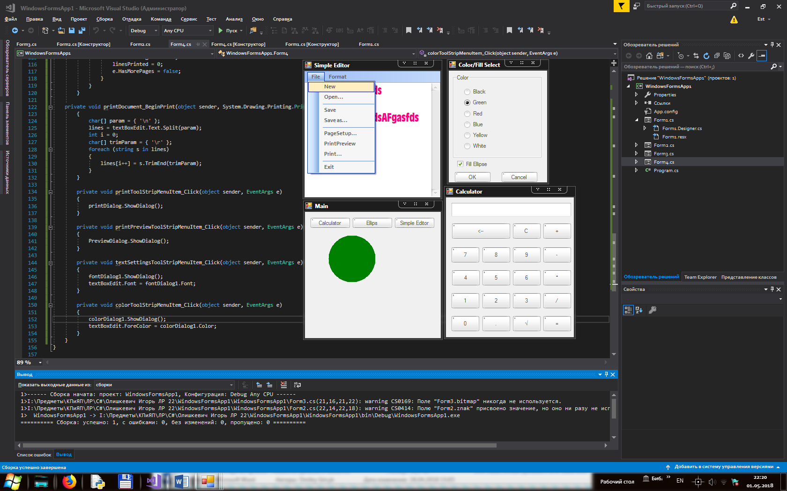

Рисунок 1 – Тестирование готового приложения